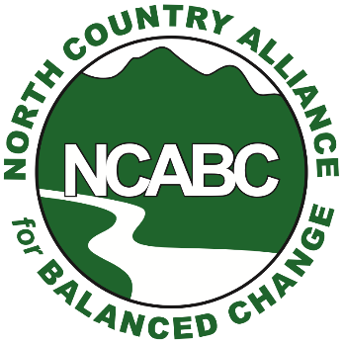
For Immediate Release
Contact:
NCABC President Eliot Wessler
eliot.wessler@gmail.com
Cell: 202-674-2416

Opponents of the proposed new mega-landfill in Dalton ask: Why is NHDES giving Casella an unprecedented do-over to help it get a wetlands permit?
Littleton, N.H. [Sept. 5, 2021] – North Country Alliance for Balanced Change and other grassroots groups opposed to the Granite State Landfill project (GSL) condemn the unprecedented action by New Hampshire’s Department of Environmental Services (DES) telling Casella Waste Systems Inc. to amend its wetlands permit, a move seemingly designed to make it easier for DES to approve permit applications for the project.

In an Aug. 26 letter to John Gay of Granite State Landfill, Rene Pelletier, assistant director of DES’ Water Division, asked Casella to submit an amended application, reflecting the first phase of the project only. This despite the fact that GSL was proposed as, and the wetlands permit was submitted to NHDES as, a three-phase project. Notably, Casella agreed the very next day.

Opponents believe that DES was likely to deny the wetlands permit as submitted due to overwhelming public opposition, a variety of deficiencies in the information provided, and the fact that the applicant had done a poor job of looking for alternative sites that would result in less wetlands destruction.

“DES had accepted the wetlands permit application as complete and had already established a hard-and-fast timetable based on their rules and regulations. Now, the result of the August 26th letter is that Casella gets a do-over—NHDES will only consider the small fraction of the environmental damage that will result from the first phase of the three-phase project,” NCABC Board President Eliot Wessler said.

“DES’ timetable was followed right up until August 26th. It held a public hearing in mid-July, it was about to close the public record on Casella's wetlands permit application in mid-September, and it said it would hand down its decision no later than the end of October,” Wessler said. “Now all of a sudden DES tells Casella to submit a slimmed-down application, and the two of them agree, without any public input, to put off a decision for a year and a half.”

NCABC believes DES and Casella agreed to this new process because a mountain of evidence piled up against the project in the public record, including:

- First, there is no public need for additional capacity in New Hampshire
- Second, the proposed Dalton landfill would put the environment and quality of life for thousands of people in the North Country at significant risk
- Third as a result of the huge leachate spill at Casella's Bethlehem landfill, there's little confidence that Casella can safely operate another landfill in the state.

“And DES did not seem to know how to handle the overwhelming public opposition to this project. So, it seems very likely that DES and Casella cooked up this scheme because DES had little choice but to deny the wetlands permit application as submitted,” Wessler said.

“The public didn't know this was going on-- but Casella must have known because it took Casella less than one day to agree to DES' August 26th letter. This smacks of a back-room deal to give Casella another chance— Casella submitted a highly flawed wetlands application and now it gets a do-over.”

Wessler added: “As far as we can tell this is an unprecedented action by DES; it is not a normal part of the permitting process. DES is segmenting the process, by looking only at the first phase of what is clearly a multi-phase project. We would like to give DES the benefit of the doubt, but the only reason we can think of why DES would do this is to make it easier for DES to defy the evidence and public opinion and permit this ill-conceived project.”

“DES’ mission is to serve and protect the people of NH, and the way to do that is for DES to look at the whole project, including all of the phases. The August 26th letter, and subsequent DES statements don’t come close to explaining why DES is doing this or changing the timetable so close to the end of the process. But the effect seems pretty clear to virtually everyone who has looked at the August 26th letter-- in a new application Casella will be able to argue that less than 17 acres of wetlands will be destroyed in the first phase of the project, and this will grease the skids for DES to approve the project. “

About NCABC

NCABC was formed in 2008 and works to advance initiatives and policies that balance the natural attributes and economic interests of Coos and northern Grafton counties. For more information about the organization, visit northcountryabc.net or find us on Facebook and Twitter.

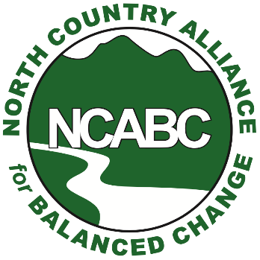
Board Members:
Eliot Wessler
Tom Tower
Sarah Doucette
Gary Ghioto
Mary Menzies
Wayne Morrison
Erik Johnson
Stephen Walker

