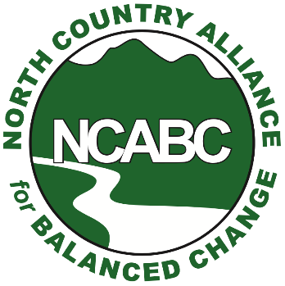
Healthy environment.
Healthy economy.
For immediate release
July 8, 2021
Contact: NCABC President Eliot Wessler
Cell: 202-674-2416
eliot.wessler@gmail.com
North Country residents and conservation groups rallying July 14 to oppose wetland permit application for proposed mega-Dalton landfill
WHITEFIELD – North Country residents and conservation groups will rally Wednesday, July 14 at White Mountain Regional High School to urge the New Hampshire Department of Environmental Services Wetlands Bureau to reject a pending permit for a 189-acre landfill in Dalton adjacent to Forest Lake State Park.
A public hearing begins at 3 p.m. at the high school to hear testimony on Casella Waste Systems Inc.’s proposal for a sprawling landfill it estimates will eventually bury 468,000 tons of garbage --- 49 percent from out-of-state annually.
A rally will be held at 2 p.m. before the full hearing.
“We expect a large crowd to show up for the July 14th hearing,” said North Country Alliance for Balanced Change Board of Directors President Eliot Wessler. “North Country people see that a large Vermont corporation is trying to ram another landfill down their throats, and they don't like it.
“Thousands of people, not only from Dalton, but also from Bethlehem, Carroll, Whitefield and Littleton are rightfully worried that yet another Casella landfill is going to really hurt their quality of life.”
NCABC expert review of Casella Waste System’s application finds the 180-acre landfill in Dalton will destroy nearly 17 acres of wetland, five vernal pools and endanger water quality in the Alder Brook stream system and the Ammonoosuc River.

Expert review conducted for NCABC by Center Sandwich, NH-based Environmental Consultants of New England concludes that the Dalton dump “would have the largest amount of aquatic resource impacts of any project in the state for at least the past ten years.”

“It would also be seven times as much as the proposed impacts associated with the failed Northern Pass,” the consultant added in a Nov. 6 letter to state Inland Wetland Supervisor Craig Rennie.

White Mountain opposition to the so-called “Granite State Landfill” is mounting due to concerns over deforestation of the untouched landfill area and significant wetland impact.

The Ammonoosuc River Local Advisory Committee voted unanimously in October 2020 to recommend the state reject Casella’s wetlands permit for the proposed facility. The state advisory panel said the site is "not a suitable location" on many fronts. The Bethlehem, Littleton and Lisbon Conservation Commissions expressed similar concerns to DES. The Ammonoosuc River serves as the prime drinking water sources for Lisbon and Woodsville.

The proposed landfill’s negative impact on local roadway safety and the regional tourism economy is also of high concern to North Country residents and businesses, Wessler said.
“They're worried about their water supplies, the smells, the dangerous chemicals, and 100 trash-hauling trucks per day barreling through their towns,” Wessler said. “They're worried that if it took Casella two days to discover a 156,000-gallon leachate spill at its Bethlehem landfill last month, that Casella is not up to operating another landfill in the area.”
The findings of a state DES investigation into the cause and circumstances of the May 1 leachate spill at Casella’s Bethlehem NCES landfill have not been released to date. The spill of the liquid, under review by the EPA as a hazardous chemical, is the largest in New Hampshire history.
“People are really angry because even DES admits there is no impending waste disposal crisis, and because up to half of the trash dumped in Dalton will be from Massachusetts and other New England states,” Wessler said. “It seems pretty clear that Casella wants to build in Dalton because it's good for Casella, not because it's good for New Hampshire.”
About NCABC
NCABC was formed in 2008 and works to advance initiatives and policies that balance the natural attributes and economic interests of Coos and northern Grafton counties. For more information about the organization, visit northcountryabc.net or find us on Facebook and Twitter.

NCABC Board

Sarah Doucette
Gary Ghioto
Erik Johnson
Wayne Morrison
Mary Menzies
Tom Tower
Stephen Walker
Eliot Wessler

