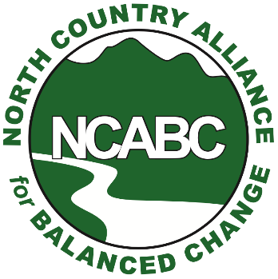
For Immediate Release
Contact:
NCABC President Eliot Wessler
eliot.wessler@gmail.com
Cell: 202-674-2416

Opposition from White Mountain towns mounting against so-called Granite State Landfill

NH State Parks director concerned about landfill odors and groundwater contamination impacting Forest Lake State Park

Littleton, N.H. [Jan. 15, 2021] – From town meeting articles to letters from local conservation commissions, opposition is mounting in White Mountain communities against a proposed mega-landfill in Dalton.

Concerns were also raised this week (Jan. 14) by the director of New Hampshire’s State Parks regarding groundwater pollution, odors, invading seagulls and blowing trash from the landfill degrading Forest Lake State Park and future plans to develop it as a campground.

“We would not want the landfill to impact water quality in the lake and in the Park for the short term or any time in the future,” writes Philip Bryce, director of the state's Division of Parks and Recreation, in a letter to NH Department of Environmental Services officials. “How do we know the landfill will not affect groundwater in perpetuity?”

Casella Waste Systems’ so-called “Granite State Landfill” would require clear-cutting some 180 forested acres in the rural town in Dalton adjacent to Forest Lake State Park, one of the state’s first state parks.

The project would destroy 17 acres of wetlands and five vernal pools, in addition to negatively impacting over a thousand feet of streams flowing to the Ammonoosuc River, according to a NCABC analysis of Casella’s pending wetlands permit.
(more-)
2.

Citing those impacts, the Lisbon, Whitefield, Bethlehem and Littleton Conservation Commissions, along with the Ammonoosuc River Local Advisory Committee, have written letters of concern and opposition to the NH DES Wetlands Bureau. (See attached). The Town of Dalton has recently hired a certified wetlands scientist to help them review and comment on the wetlands permit application.

Lisbon officials are concerned about runoff from the landfill and leakage from the landfill’s liners contaminating the Ammonoosuc River that the town depends on for its water supply. Woodsville also depends on the river for drinking water.

Whitefield’s letter focuses on the proposed landfill’s proximity to the town’s well and worries that a leachate spill from the landfill could damage Forest Lake.

Littleton conservation officials strongly advise NH DES to “abide by its own mission statement” to protect the state’s environment and reject Casella’s landfill project.

A recent traffic study by Casella confirms that an estimated 204 daily trips to and from the
Landfill to Dalton on an average day by massive garbage-haulers would roll through the centers of Littleton, Bethlehem, Carroll and Whitefield.

A town meeting article before Carroll voters this spring opposes the landfill due to its negative impacts on tourism, highway safety and area lakes, rivers and streams.

Littleton town meeting voters will consider a non-binding article opposing the landfill and urging DES to reject the Casella project.

“It is encouraging and critical to see region-wide opposition to the Dalton dump proposal growing week by week,” NCABC board member Sarah Doucette said. “The project is undeniably contrary to our local towns’ master plans and our New Hampshire state agencies' mission statements.

“It is being recognized for the broad and lasting damage it will bring to the north country’s environment, public health and tourism industry. It should be stopped by both public outcry and regulatory action before it advances any further.”

For media comment and more information, contact NCABC.

About NCABC

NCABC was formed in 2008 and works to advance initiatives and policies that balance the natural attributes and economic interests of Coos and northern Grafton counties. For more information about the organization, visit northcountryabc.net or find us on Facebook and Twitter.

Attachments:

Jan. 14 letter by NH State Parks Director Philip Bryce
Whitefield, Littleton, Bethlehem Conservation Commission letters.
Carroll Town Meeting petition article
Ammonoosuc River Advisory Committee report
NCABC news releases

